Payments Received report

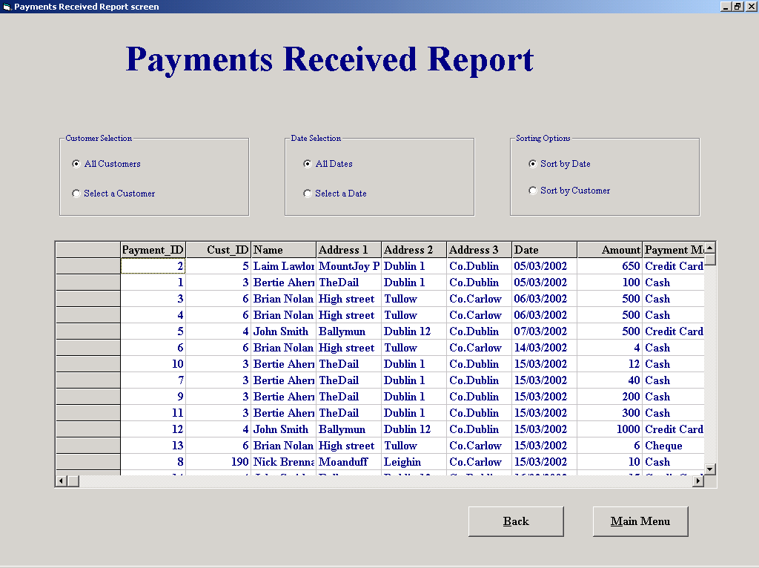

Purpose of the screen
To display a number of reports related to the monies received from customers, sorted by customer number or by date

How to get to the screen
Select the “Reports” option on the ‘Main Menu’ followed by the “Payments Report” option on the reports menu.

How to use the screen

There are six options for displaying the Payments report

List all customers
      - List all Dates
      - List a selected Customer
      - List Customers on a selected date
      - Sort by Customer ID
      - Sort by date
A combination of the options shown on the screen will display the selected selected out put, however to select a customer you need to search for that customer, and to select a specific date you need to input the date

Selecting a date
When you select the “Select a date” option a ‘Date Picker’ screen is displayed select the date and then confirm the date by selecting the “Confirm” button

Selecting a customer
- When you select the “Select a Customer “ option a small screen will appear in the center of the main screen this screen allows you to search for a customer
- A customer can be searched for by name or number
- If you wish to select to search for a customer by name (this is the default and is selected automatically when the screen opens) select the “Search using Customer’s Name “ option
- Then either
- View a list of all possible names of customers who have accounts with the company by selecting the down arrow on the right of the data input box marked “Enter Customer name”
- Then select a name by clicking on it (To allow a quick search the names are sorted alphabetically)
- When a name has been selected it will appear in the data input part of the input box
- Or
- Alternatively type any part of the name in to the data input part of the input box marked “Enter Customer name”
- If you wish to select to search for a customer by ID number select the “Search using Customer’s Number “ option
- View a list of all possible ID numbers of customers who have accounts with the company by selecting the down arrow on the right of the data input box marked “Enter Customer name”
- Then select a name by clicking on it
- When a ID number has been selected it will appear in the data input part of the input box

- Select the “Display Customer” Button and another screen will overlay the customer search screen this is the confirmation screen.
- The ‘first match’ of the customers details will be displayed in the data input boxes allowing you to confirm the details are correct either from your own knowledge of the customer or by asking the customer to confirm his address etc
- If you have selected the “Search using Customer’s Name “ option and there is more than one match of the name entered then a box will appear with “The number of customers matching the search criteria” shown in the confirmation screen. There are two buttons on this box “Display Next” and Display Previous”. Selecting either buttons allows you to move through the customers displaying their full details. Once the customer has been identified the “Confirm” button should be selected, this makes both the “Customer Search” screen and the “Confirm Screen” fade away.
- Select the “Main Menu”(alt-M) to return to the main menu.
- Select the “Back”(alt-B) to return to the screen that you entered this screen from in this case it has to be the Reports menu.

